103年度民專訴字第54號

附圖一：系爭專利主要圖式
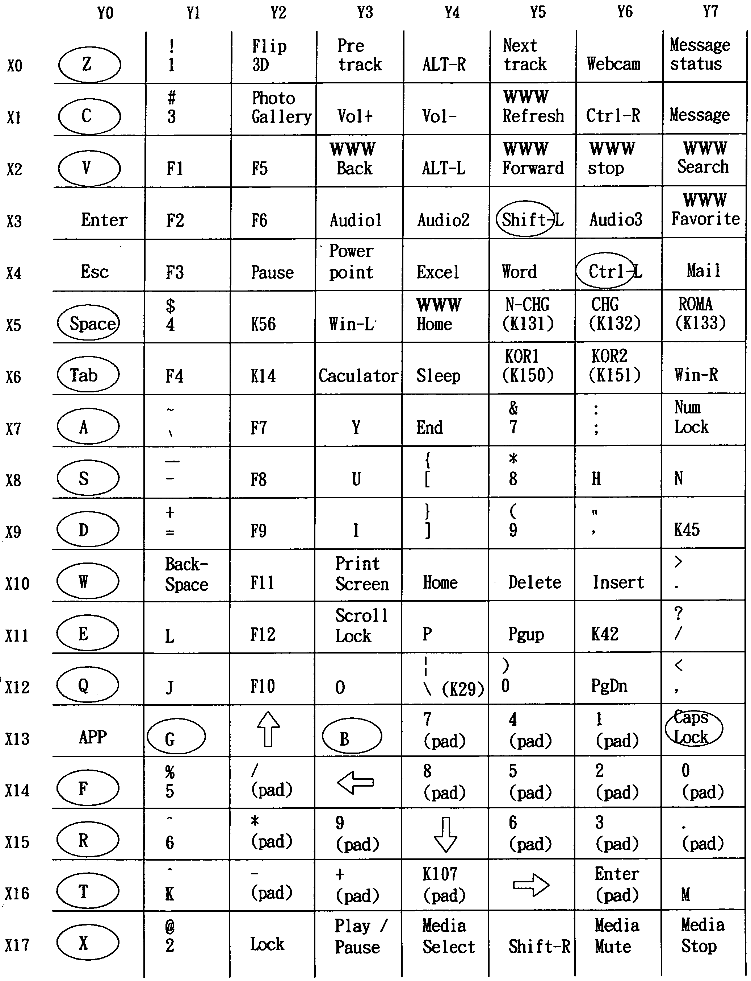

附圖二：系爭產品「夜行者」電競鍵盤照片


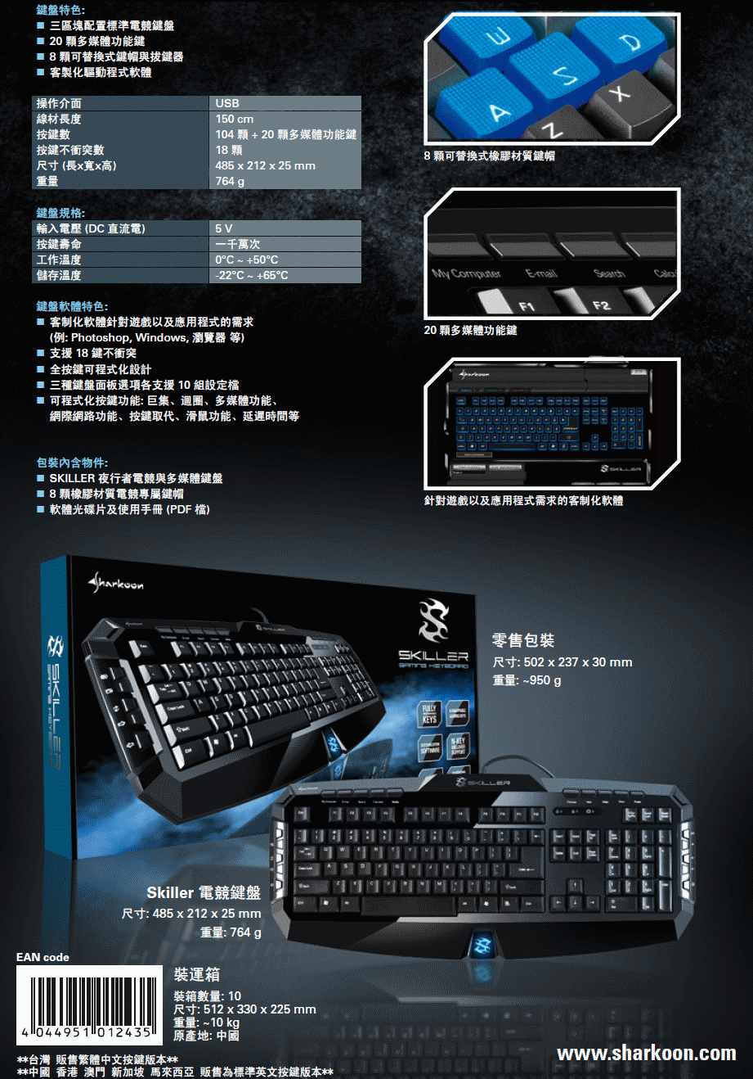

附圖三：引證1第1圖
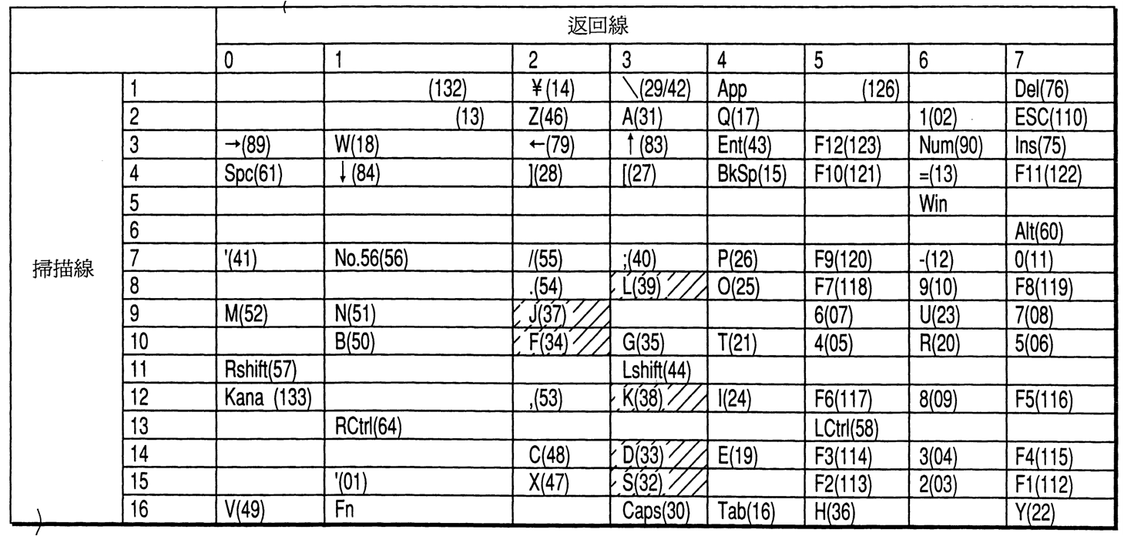

附圖四：引證2第五圖（第二具體實施例）
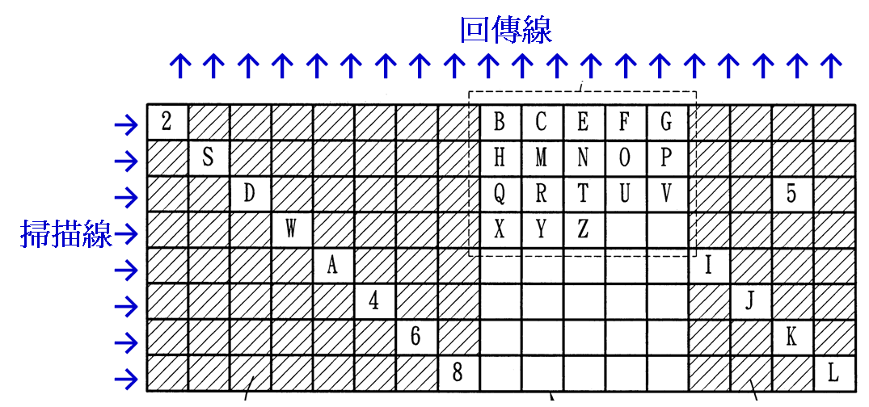

附圖五：引證4圖2
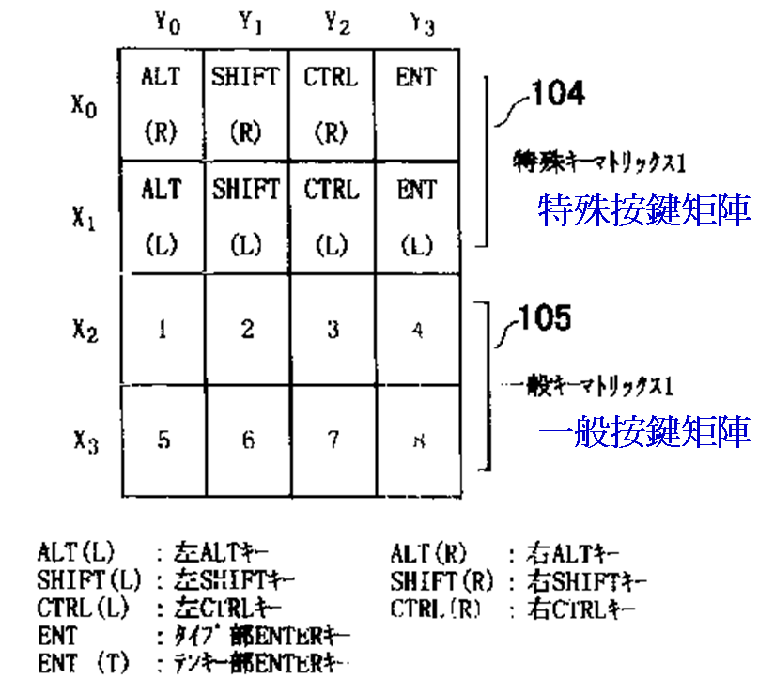

附圖六：系爭產品按鍵的定義（見原告所提103 年11月24日民事準備狀附件十六）
Item Tag (Value) | Raw Data
Usage Page (Generic Desktop) | 05 01
Usage (Keyboard) | 09 06
Collection (Application) | A1 01
Report ID (3) | 85 03
Report Count (56) | 95 38
Report Size (1) | 75 01
Logical Minimum (0) | 15 00
Logical Maximum (1) | 25 01
Usage Page (Keyboard/Keypad) | 05 07
Usage Minimum (Keyboard Left Control) | 19 E0
Usage Maximum (Keyboard Right Control) | 29 E7
Usage Minimum (Undefined) | 19 00
Usage Maximum (Keyboard [ and {) | 29 2F
Input (Data,Var,Abs,NWrp,Lin,Pref,NNul,Bit) | 81 02
End Collection | C0
Usage Page (Generic Desktop) | 05 01
Usage (Keyboard) | 09 06
Collection (Application) | A1 01
Report ID (4) | 85 04
Report Count (56) | 95 38
Report Size (1) | 75 01
Logical Minimum (0) | 15 00
Logical Maximum (1) | 25 01
Usage Page (Keyboard/Keypad) | 05 07
Usage Minimum (Keyboard ] and }) | 19 30
Usage Maximum (Keyboard =) | 29 67
Input (Data,Var,Abs,NWrp,Lin,Pref,NNul,Bit) | 81 02
End Collection | C0

附圖七：原告所提陳報（三）狀附件八同時按壓1、2、3、4、Q、W、E、A、S、D等10個按鍵時，測試程式收到「03 00 90 01 50 C4 03 00」，其中第一個「03」為Report ID。
按鍵 | ID | Byte 2 | Byte 3 | Byte 4 | Byte 5 | Byte 6 | Byte 7 | Byte 8
1 | 03 | 00000000 | 00000000 | 00000000 | 00000000 | 01000000 | 00000000 | 00000000
2 | 03 | 00000000 | 00000000 | 00000000 | 00000000 | 10000000 | 00000000 | 00000000
3 | 03 | 00000000 | 00000000 | 00000000 | 00000000 | 00000000 | 00000001 | 00000000
4 | 03 | 00000000 | 00000000 | 00000000 | 00000000 | 00000000 | 00000010 | 00000000
Q | 03 | 00000000 | 00000000 | 00000000 | 00010000 | 00000000 | 00000000 | 00000000
W | 03 | 00000000 | 00000000 | 00000000 | 00000000 | 00000100 | 00000000 | 00000000
E | 03 | 00000000 | 00000000 | 00000001 | 00000000 | 00000000 | 00000000 | 00000000
A | 03 | 00000000 | 00010000 | 00000000 | 00000000 | 00000000 | 00000000 | 00000000
S | 03 | 00000000 | 00000000 | 00000000 | 01000000 | 00000000 | 00000000 | 00000000
D | 03 | 00000000 | 10000000 | 00000000 | 00000000 | 00000000 | 00000000 | 00000000
輸出 | 03 | 00000000 | 10010000 | 00000001 | 01010000 | 11000100 | 00000011 | 00000000
輸出 | 03 | 00 | 90 | 01 | 50 | C4 | 03 | 00

