附圖1（證據2 圖式）
FIG. 1 is an exploded view of the first embodiment of the subject invention.
FIG. 2 is an assembled side section view of the first embodiment of the subject invention.
FIG. 3 is an illustration of another embodiment of the block piece in the subject invention.
1 hollow housing | 3 slide mechanism | 33 second slide block | 42’air hole
11 opening | 31 first slide block | 331 protruding piece | 5 driving unit
12 fixed block | 311 protruding piece | 332 protruding post | 51 hollow shaft sleeve
13 fixing component | 312 protruding post | 34 pressing block | 52 joining rod
14 air inlet | 312air channel | 4 block piece | 53 C-clamp
15 washer | 314 washer | 41 V-channel | 54 turning knob
16 bolt | 32 middle plate | 42 air hole | 541 vent
2 cover | 321 joining hole | 511 spiral shaped slide channel
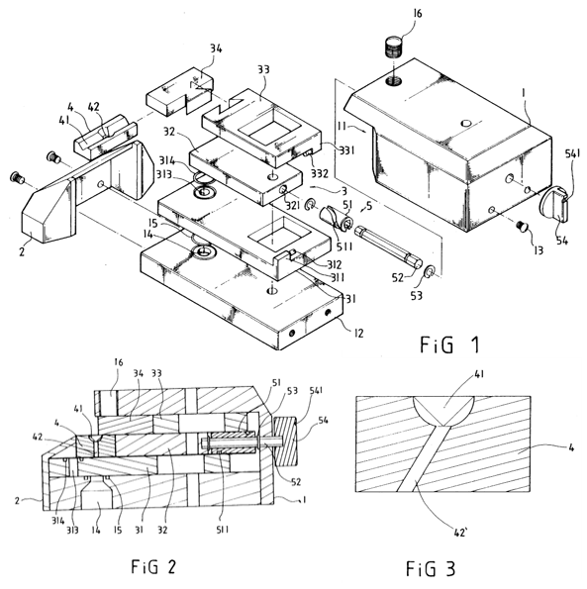

附圖2（證據3 圖式）
證據3第26頁型號DH-2622 [Φ1.2] J02三角形噴嘴
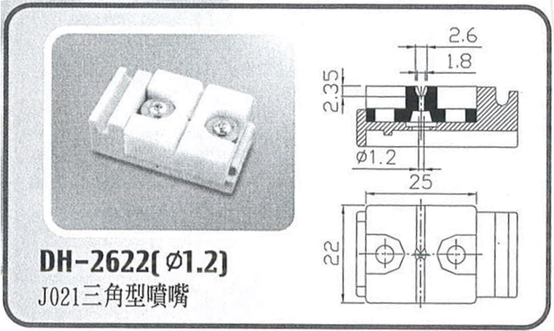

證據3第26頁型號DH-02 [Φ1.4] J021半圓噴嘴
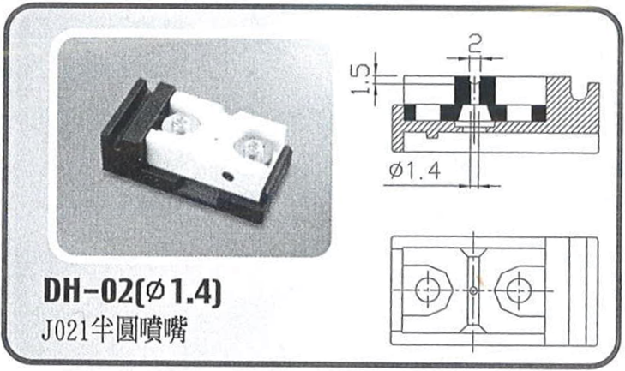

證據3第26頁型號DH-223 [Φ1.6] J021三角型噴嘴
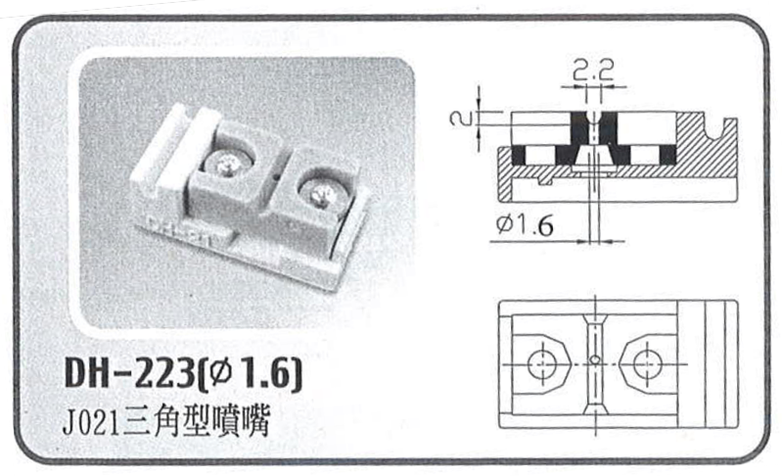

證據3第05頁型號DH-J020 CLOSED TYPE噴嘴
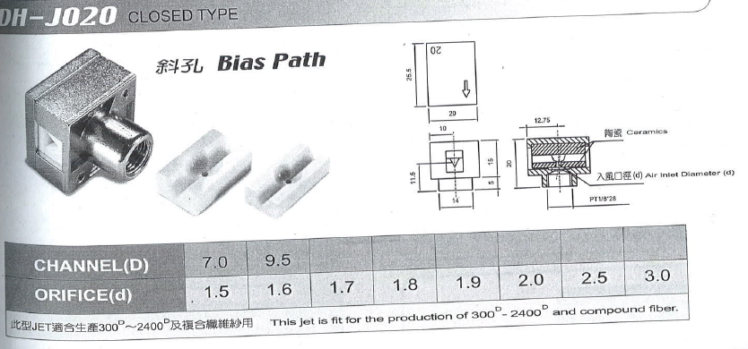

證據3第03頁及05頁型號DH-J021 噴嘴及其分解圖
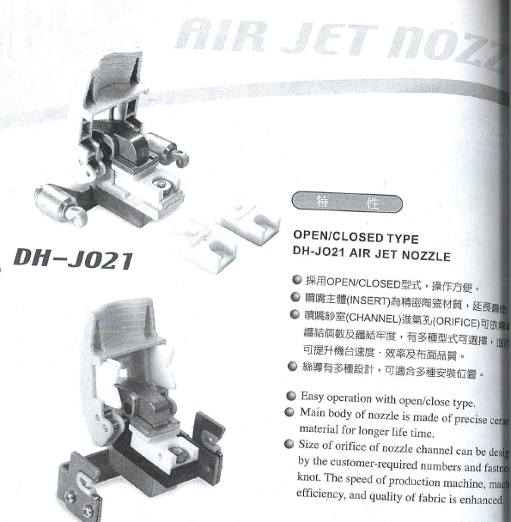

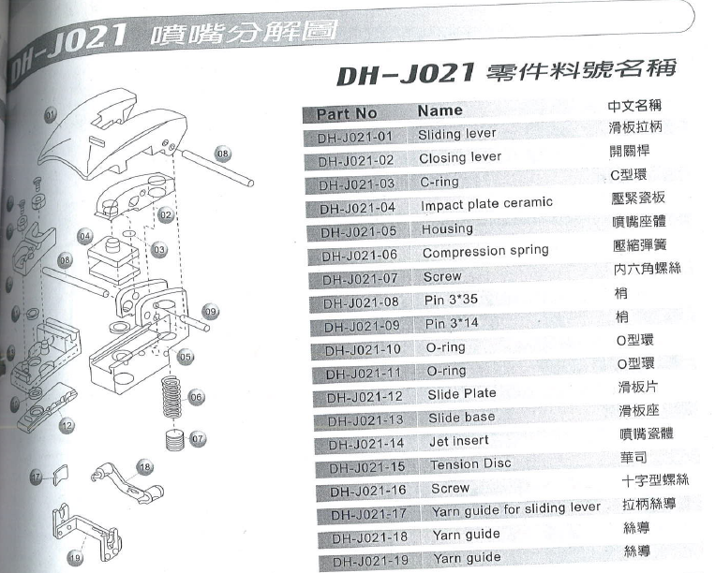

【附圖3：系爭專利第13a 至13d 、14b 、14c 圖之先前技術】



