編號 | 圖片 | 名稱 | 市價〈NT〉  RMB×4.5 | 數量 | 總額〈NT〉
1 | 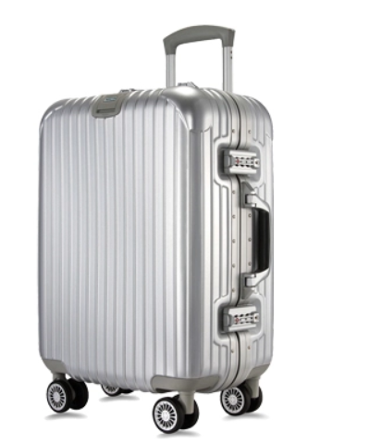 | #013 | RMB429 | 811 | 1,565,635.5
2 | 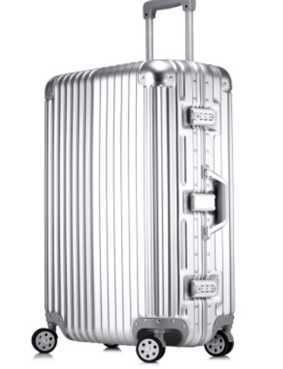 | #017 | RMB408.6 | 214 | 393,481.8
3 | 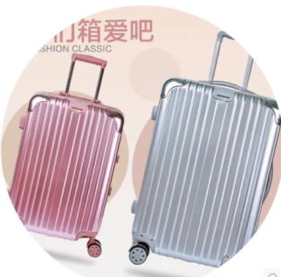 | SF023 | RMB393.6 | 522 | 624,566.4
4 | 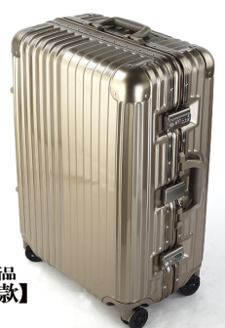 | _LUGGAGE (ABS/PC製) SF018 (森騰商標) 20/24 | RMB458 | 395 | 814,095
5 | 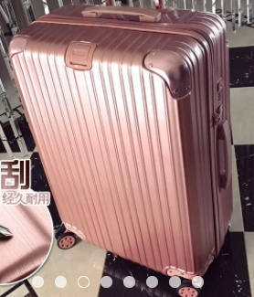 | _PC製拉桿箱 SZ002 LUGGAGE-24吋 | NT2,800 | 4 | 11,200
6 | 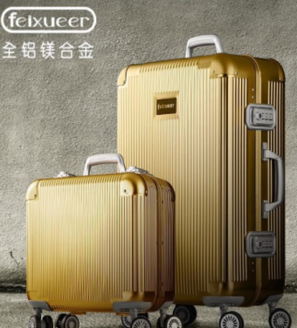 | F1004 | RMB100 | 197 | 19,700
7 | 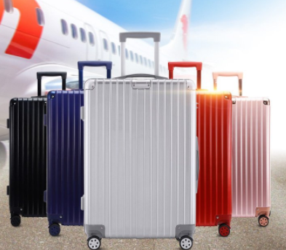 | BRI8001 | NT2,300 | 668 | 1,536,400
8 | 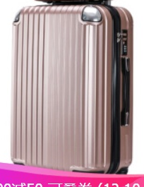 | ABS製9827 | RMB399 | 599 | 1,075,504.5
9 | 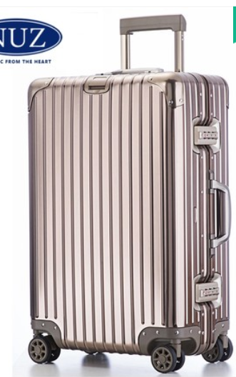 | 5568水晶紫 | RMB3,085 | 70 | 971,982.9
10 | 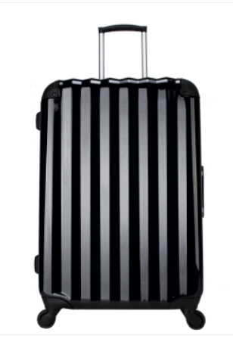 | 5611 | RMB728 | 130 | 425,880
11 | 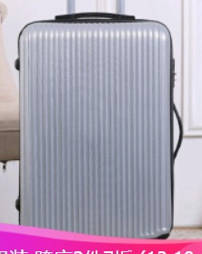 | 8063 | RMB312 | 198 | 277,992
12 | 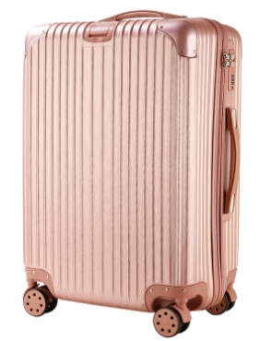 | ABS/PC製 F003(20/24/28) | RMB119 | 2,118 | 1,134,189
13 | 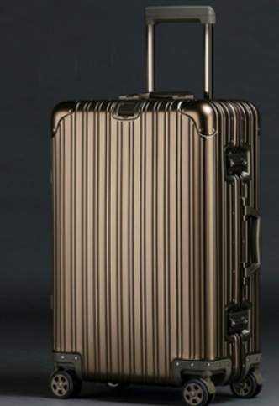 | AOU0809 外殼ABS材質 | RMB1,188 | 1,500 | 8,019,000
14 | 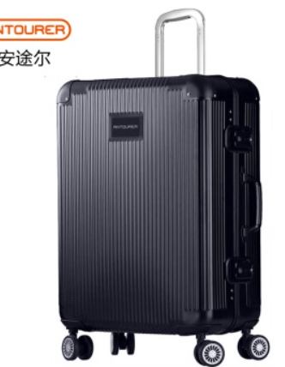 | F10004 | RMB1,799 | 6 | 48,573
15 | 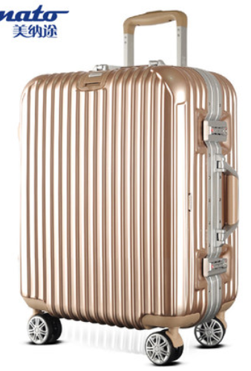 | G18(SF006) 20/28吋 | RMB338 | 222 | 337,662
16 | 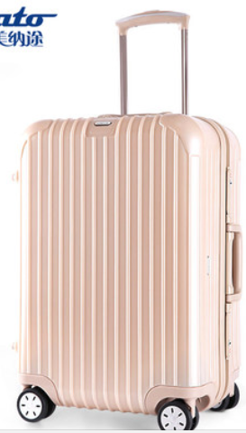 | G20 LUGGAGE-24" | RMB996 | 827 | 3,706,614
17 | 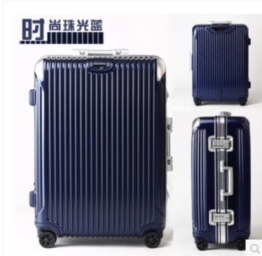 | SF006 24/28LUGGAGE-套裝 | RMB468.12 | 76 | 160,097.04

