編號 | 圖片 | 名稱 | 市價〈NT〉  RMB×4.5 | 數量 | 總額(NT)
1 | 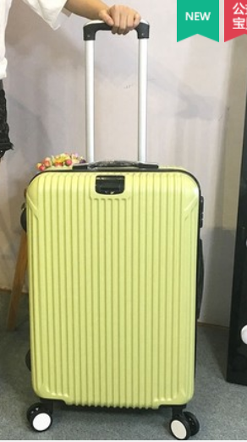 | 2592 | 6,494 | 10 | 64,940
2 | 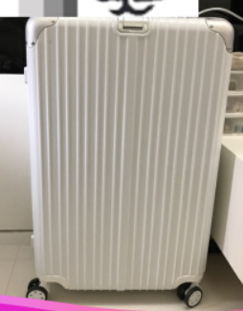 | 4681 | RMB940 | 90 | 380,700
3 | 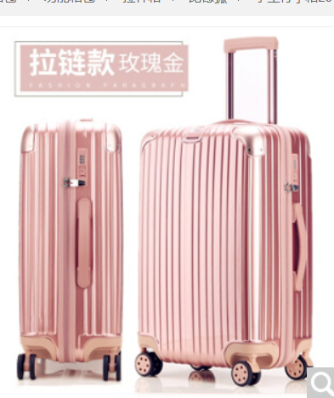 | 5583 | RMB462 | 60 | 124,740
4 | 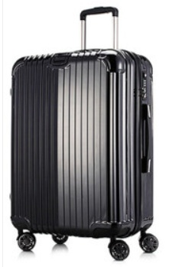 | 5621 | RMB2,211 | 110 | 1,094,445
5 | 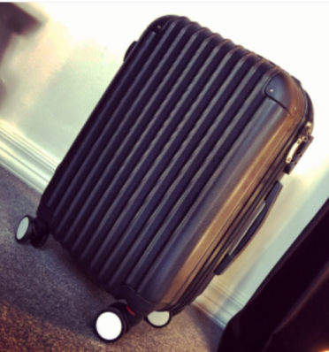 | 5644 | RMB227 | 88 | 89,892
6 | 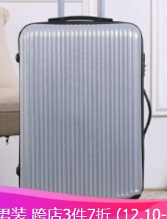 | 8063 | RMB312 | 113 | 158,652
7 | 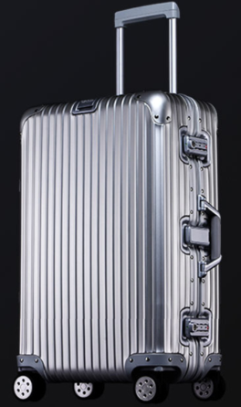 | 8445 | RMB1,795 | 220 | 1,777,050
8 | 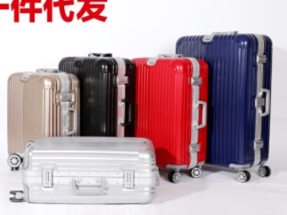 | #017 | RMB918 | 1,800 | 7,435,800
9 | 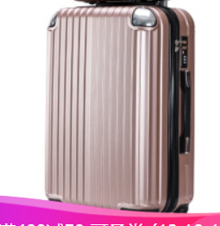 | _ASB/PC製旅行箱 9827 TROLLEY LUGGAGE 22" | RMB399 | 555 | 996,502.5
10 | 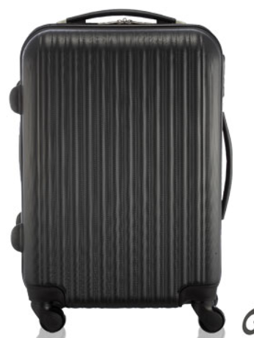 | _ASB回收料製旅行箱 90-006 TROLLEY LUGGAGE 20" | NTD672 | 314 | 211,008
11 | 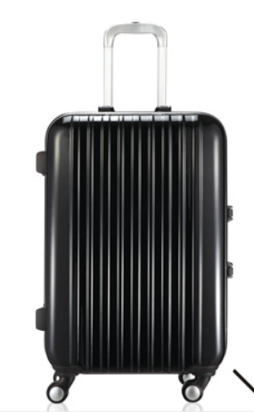 | _ASB回收料製旅行箱 90-012 TROLLEY LUGGAGE 29" | NTD2,380 | 33 | 78,540
12 | 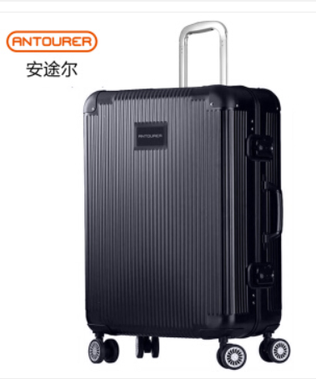 | _TROLLEY LUGGAGE _金屬鋁合金製拉桿箱 _BRAND: FEIXUEER F10004-29吋 | RMB1,799 | 114 | 922,887
13 | 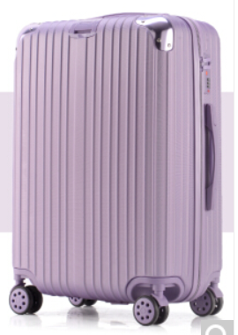 | 8397-26" ABS/PC硬殼箱 | RMB298 | 8 | 10,728
14 | 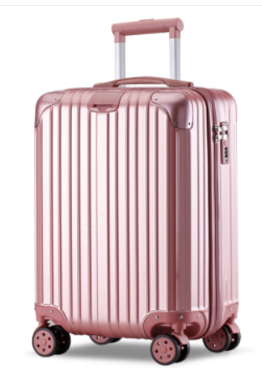 | 8420 20" | RMB191 | 37 | 31,801.5
15 | 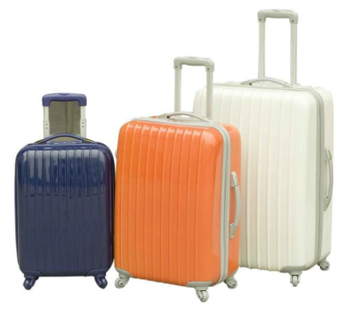 | F005 | US56.5  (3件組) | 51 | 28,815
16 | 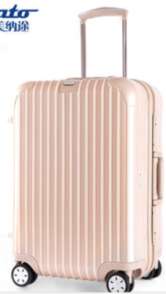 | G20 | RMB996 | 937 | 4,199,634
17 | 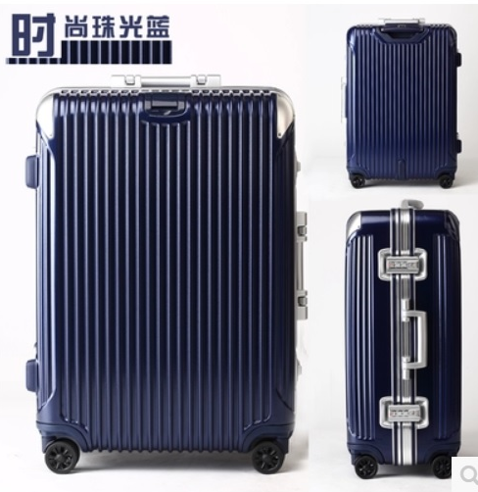 | _BRAND:SENTENG森騰 SZ006 28"/24"/20" LUGGAGE | RMB468.12 | 24 | 50,556.96

